**GPS Logger Development Using Microcontroller**

Purwowibowo, Sensus Wijonarko, Tatik Maftukhah

Pusat Penelitian Fisika LIPI, Kompleks Puspiptek Serpong, Tangerang, Banten 15314

Email:[purwowibowo@yahoo.com](mailto:purwowibowo@yahoo.com)

_______________________________________________________________________________________

Abstract

Although the applications of GPS navigation have been widely used, the implementations of GPS logger currently are still very scarce. GPS loggers are able to keep locations in form of coordinates and UTC, so that the data might be accessed later on using SD cards equipped in the devices. The purpose of this research was to create a GPS logger using an open source microcontroller system to maintain flexibility for operating. An Arduino board Mega ADK and a GPS shield Ublok-Lea 6H ware used. Furthermore the device was provided with a Thin Film Transistor (TFT) display and a SD module. The received data ware displayed on the TFT in coordinates of latitude, longitude and altitude. To get the accuracy level, measurement results of the GPS logger was compared with measurement results from other GPS products in several places. According to the comparison, the average error of the GPS logger was less than 2 meters.

**Keywords:** GPS logger, Microcontroller, SD card, Arduino, TFT

*Abstrak*

*Meskipun aplikasi-aplikasi GPS navigasi sudah banyak digunakan, tetapi penerapan GPS logger saat ini masih sangat jarang.* GPS logger *ini dapat menyimpan lokasi dalam bentuk koordinat dan UTC, sehingga data dapat diakses kembali melalui* SD card *yang dipasang di alat tersebut. Tujuan penelitian ini adalah untuk membuat* GPS logger *dengan menggunakan sistem mikrokontroler yang open source guna menjaga kelenturan pemakaian. Digunakan Arduino board Mega ADK dan GPS shield Ublok Lea-6H. Sistem ini dilengkapi dengan penampil Thin Film Transistor (TFT) dan modul* SD card*. Data yang diterima ditayangkan di layar TFT dalam bentuk koordinat lintang utara, bujur timur, dan ketinggian. Untuk mendapatkan tingkat ketepatan, hasil-hasil pengukuran* GPS logger *tersebut dibandingkan dengan hasil-hasil pengukuran produk GPS lain di beberapa tempat. Berdasarkan perbandingan, kesalahan rerata dari* GPS logger *ini kurang dari 2 meter.*

**Kata kunci:** GPS Logger, Mikrokontroler, SD card, Arduino, TFT.

_______________________________________________________________________________________

**1. INTRODUCTION**

Many researches at present in sciences such as metrology, geophysics, and aeronautic are using sensors and data loggers. To get accurate results, the data storage is one of the most important processes in the data logger applications [5].

Applications of global positioning system (GPS) have been widely used especially for navigation in vehicles by the Indonesian communities, but the GPS that is utilized as a logger is rarely used. The purpose of data logging is to store data that can be later accessed. In this case, the GPS logger will store the location in the form of coordinate and time on a SD card, so that it can be accessed again when needed.

In this project, the GPS logger was made using an Arduino board and a GPS shield, and then is equipped with a TFT screen and an SD card module to display and store data. This GPS was run with an open source software for the sake of easiness to adapt to existing functions.

In this paper, the design and principle of work of the GPS logger prototype that uses a microcontroller system will be explained. Besides, the process of data collection and comparison accuracy with other GPS on the market are also discussed.

**2. LITERATURE REVIEW**

This section will explain the GPS system, microcontroller that uses an Arduino device, and device that displays and stores data.

**2.1. GPS**

GPS is a system dedicated to determine the location on the earth surface with the assistance of satellite signal alignments continuously throughout the world regardless of weather conditions. This system has four basic factors, namely latitude, longitude, altitude, and time. This system uses a number of satellites that move around the earth. These satellites send microwave signals to the Earth. From these signals, the GPS reads information provided by the satellite and determines the location, speed, direction, and time on the GPS itself.

GPS information can also be obtained by the pythagorean formula as[3]:

$$Prs+T+Es=\sqrt{{\left(X - Xs\right)}^{2} + {\left(Y - Ys\right)}^{2} + {\left(Z - Zs\right)}^{2}}$$

T = Time error receiver

X, Y, Z = Unknown position

XS, YS, ZS = Position of satellites known by other satellites

Es = Total number of modeling errors from GPS

Prs = Received approximate distance between the receiver and satellite

T = Receiver time error

In this study, the GPS Shield ublox LEA-6H for Arduino Uno (Figure 1) is utilized as a GPS device, that then is connected to the Arduino Mega ADK. The GPS device is a GPS signal receiver designed for Arduino, has accuracy, anti-jamming technology, power safe mode, backup power, and is able to receive from weak signals [6].

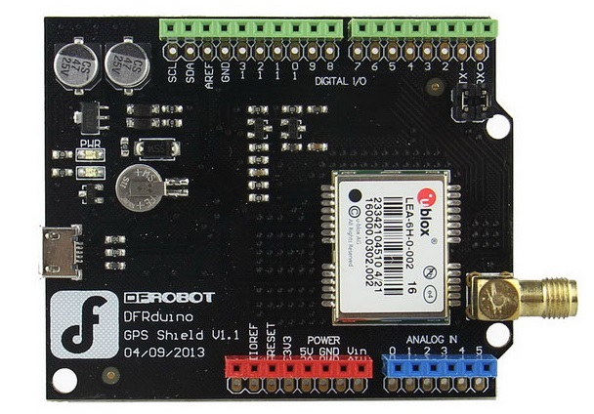

**Figure 1**. GPS Shield ublox LEA-6H[6]

The connection between GPS shield and Arduino Mega uses an I2C system by connecting the SDA (pin 20) and SCL (pin 21) pins on Arduino mega to the SDA and SCL pins on the GPS respectively.

# 2.2. Microcontroller

Microcontroller, such as Arduino, is a computer system that works in a chip. The microcontroller contains a processor core, memory and input/output port that can be programmed using software. In this research, Arduino Mega ADK (Figure 2) is used as a microcontroller device. The Arduino Mega is a microcontroller board based on ATmega2560. It has 54 digital input/output pins, a 16 MHz Quartz crystal, USB port, ICSP header and reset button. The Arduino can be turned on by connecting this processor to a computer via a USB port, to a battery, or to AC supply via a DC adapter. The Arduino Mega has a much greater capacity than the Arduino Uno. Hence, it can contain larger programs. The Arduino board is designed able to work using the Arduino Uno's shield. The Arduino can be programmed with Arduino Software downloaded for free at <https://www>. arduino.cc/en/Main/Software, and then choose the appropriate Arduino board in the tools that available in the software [4].

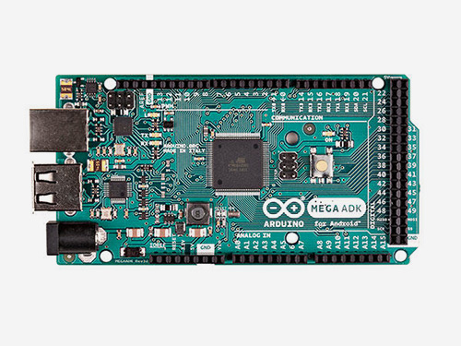

Figure 2. Arduino Mega ADK[4]

The circuit configuration and mapping of the pins for an Arduino Mega ATmega2560 microcontroller are shown in Figure 3 below.

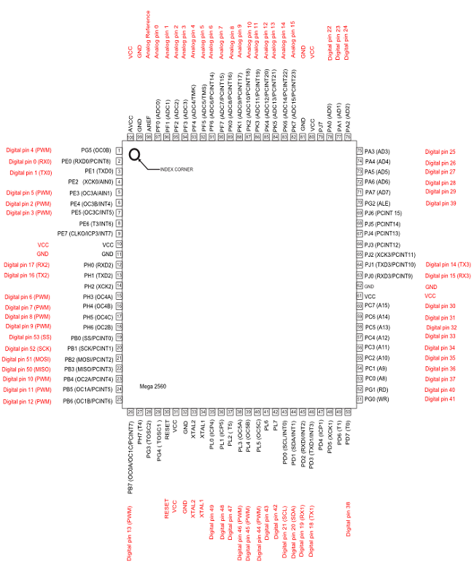

**Figure 3.** configuration and mapping of the pins for an ATmega2560 microcontroller [4] [7]

# 2.3. Data Logging

Logging is a process of collecting data and storing it in memory for a certain period of time. In this study, SD cards are used as memory to store data sent from GPS via Arduino, so that data can be accessed via an SD card connected to a computer.

In this experiment, the SD card breakout (Figure 4)is used as a tool to store data in the SD card. The SD card module uses a serial peripheral interface (SPI) connection to communicate with Arduino, through CS pins (53), MOSI (51), MISO (54), SCK (52) found in Arduino Mega.

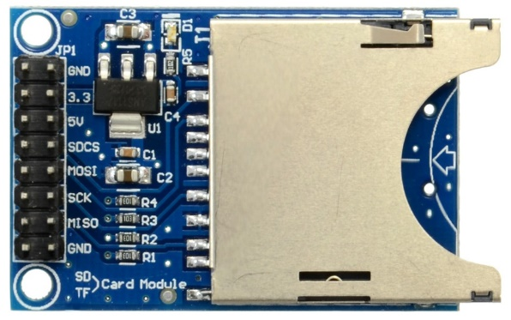

Figure 4.Arduino SD card breakout

**2.4. Display**

The device used to display results in this project is a TFT Iteadstudio product (Figure 5.) equipped with a shield for Arduino Uno. In this experiment, the shield is directly connected to the Arduino Mega ADK without the need for an additional wiring. The TFT is used as a means to display results because it has a high resolution. Therefore, it is able to display data with smaller sizes than ordinary LCDs.

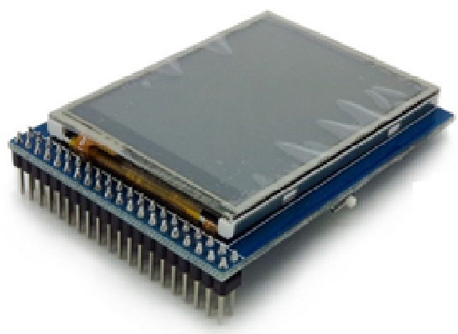

Figure 5.Arduino TFT display

**3. GPS CIRCUIT DESIGN AND CONSTRUCTION**

**3.1. Materials**

The Arduino Mega ADK microcontroller is used as a processor that receives position data from satellites via the GPS shield. The position data is displayed on the screen to find out the position directly. The data, then, are also stored in the SD Card memories.

The block diagram of the GPS Logger prototype is presented on Figure 6.

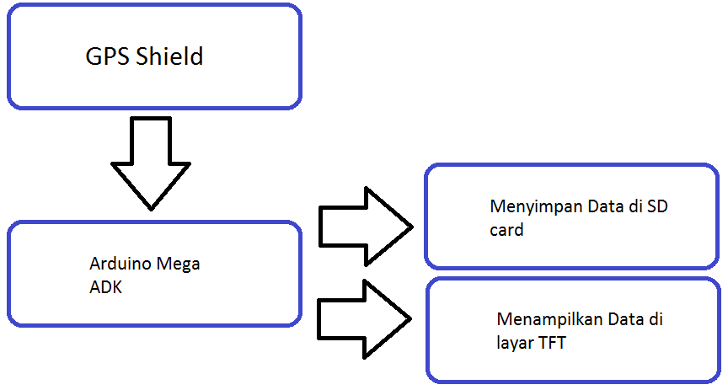

Figure 6. The Block diagram of the GPS logger system working order

The block diagram in Figure 6 shows the systematic work, so the devices can be arranged in such a way in the Figure 7 and Figure 8.

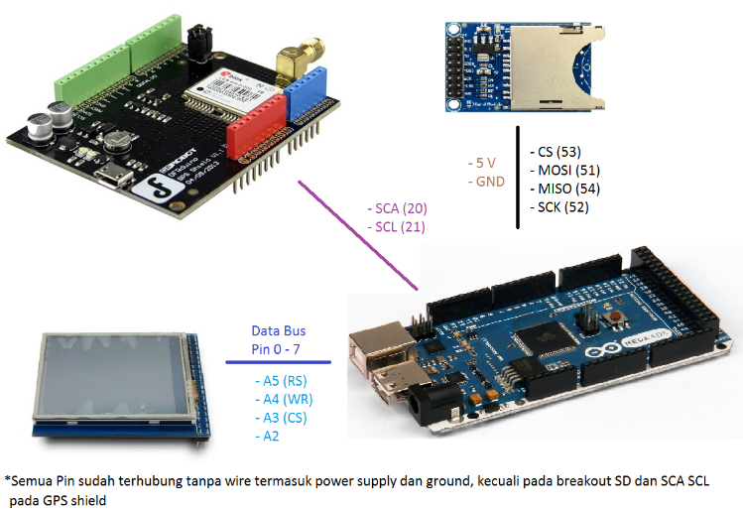

Figure 7. Arrangement of Device Pins

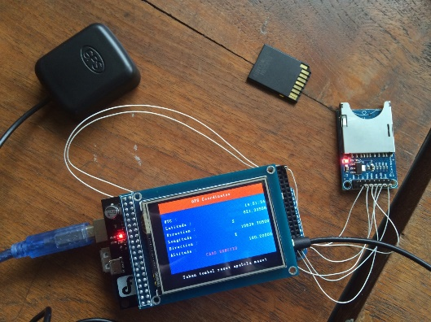

Figure 9. GPS logger equipped with an antenna

The flow chart to make the program is presented on Figure 9.

Start

- include header

- define function

- variable declaration variabeleclaratio

Give command:

- data transfer

- GPS initialization

- ID receiver

- UTC

- receive function data

- latitude

- arah latitude

- longitude

- arah longitude

- altitude

- TFT on

- Display background

- Check the connection to SD

Get data fromi GPS:

- UTC

- latitude

- latitude direction

- longitude

- longitude direction

- altitude

- Display data to TFT

- Send obtained data to SD card

Figure 9. GPS diagram

Arduino Software is an open source based programming software used to create programs that can be compiled/verified and then can be uploaded to Arduino which is connected through the port. Hence, it can work according to the functions contained in the program (Figure 10).

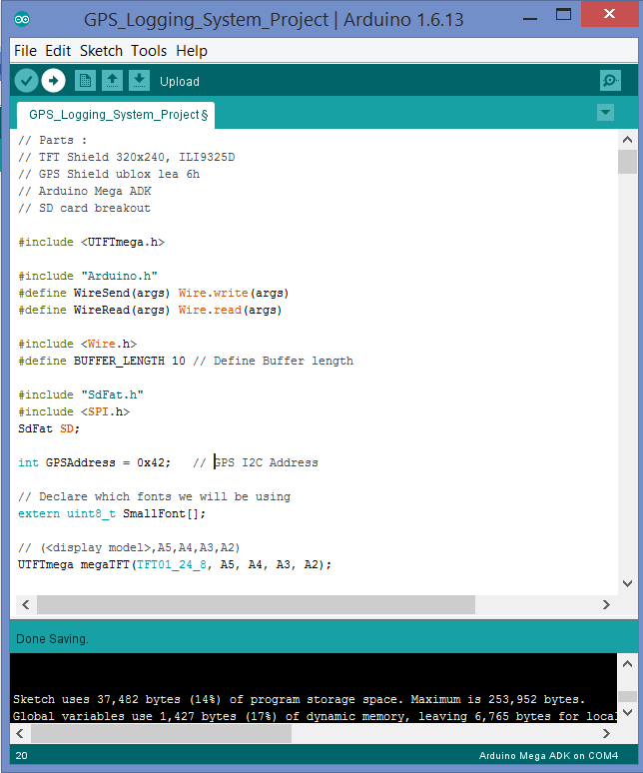

**Figure 10.** Arduino Software

The following program requires a library that must be downloaded, because it is separated from the Arduino software, namely SDfat library and UTFT library. To use the separate library, move the library folder to the Arduino> libraries folder, so that the library can be called into the program. The UTFTmega library below is a regular UTFT library, where the define function for Arduino Mega has been uncommanded. Therefore it is compatible with Arduino Mega (Figure 12). The file is located in the UTFT> Hardware> AVR> HW_AVR_Defines folder. The library is renamed before being added to the library to make it easier to use and to prevent exchange with the regular UTFT library.

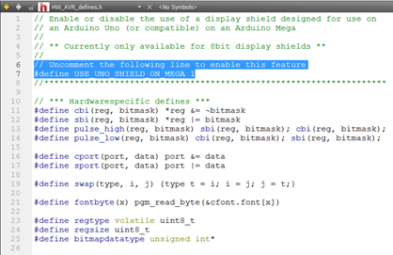

Figure 12. Program to define an Arduino board as a mega Arduino

3.2. Measurement **Method**

The measurement was carried out on 11-17 and 24 January 2017 in Jakarta, and on 30 January 2017 at PUSPIPTEK. Measuring instruments used as the accuracy comparison are the 60CSx Garmin GPS, 78s Garmin GPS, and iPhone 5S mobile phones (Figure 12 and Figure 13).

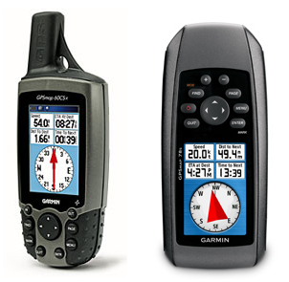

Figure 12. Garmin 60CSx and Garmin 78s

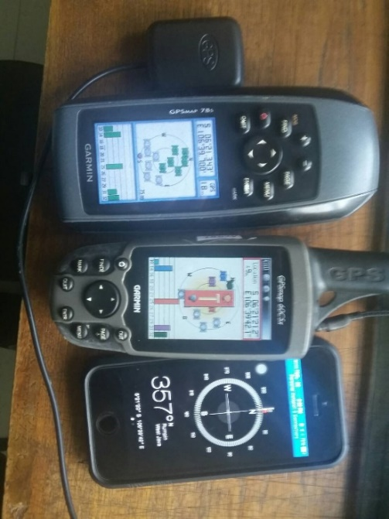

**Figure 13. Equipment arrangement**

Data gathering was conducted on January 11-17 with temperature between 26 °C and 40.1 °C and humidity between 44 % and 87 %. This weather conditions did not give any influence to the comparison process of the GPS.

The equipment was turned on a few minutes as a warming up before the data collection. This equipment, then, was arranged as in the Figure 13 and placed in the same open location. Data were recorded manually from the left to right every hour for 24 times. The data collection, then repeated until there are 72 data.

Data collection on January 24 and January 30 was carried out to test GPS accuracy in various places using other GPS devices as a comparison.

# 4. RESULTS AND DISCUSSION

The results of the GPS data are arranged in a table in the form of coordinates and length units for altitude/elevation accompanied by humidity and temperature data for the collection of 72 data. Then, 10 data at Monas and Ancol respectively ware taken every 2 minutes, while the data collection at PUSPIPTEK area were obtained every minute.

Coordinate measurement results have the following units:

Lat = Latitude (degree° minute′ second′′)

Lon = Longitude (degree° minute′ second′′)

Alt = Altitude (meter)

Elev = Elevation (meter)

S = South

E = East

N = North

W = West

Temperature (celcius)

*minutes and seconds in this paper are not in a time scale, but they act as a coordinate in the gps system, namely 1 degree = 60 minutes, 1 minute = 60 second.

From the measurement data, it is seen that the 60csx and iphone garmin display data with degrees, seconds, and seconds while the GPS suba lea6H and garmin 78s display only degrees and minutes in decimal form. So to compare the accuracy of the data, they must first be converted to meters and then are substracted.

It is already known that the circumference of the earth is 40075,017 km (equatorial) and 40007.86 km (meridional) [2]. Equatorial earth circumference means the distance of the earth's circumference is measured from the equator and meridional is measured from pole to pole. For calculation of latitude, meridional and longitude are used using equatorial. The following is the calculation of the conversion of coordinates to meters:

Latitude:

360° = 40007.86 km

1° = 40007.86/360= 111.13294 km

1 min = 111.13294/60 = 1.85221567 km

1 sec = 1.85221567/60= 0.03087026117 km

Longitude: 360° = 40075.17 km

1° = 40075.17 / 360= 111.3199167 km

1 min = 111.3199167/60= 1.855331945 km

1 sec = 1.855331945/60= 0.03092219908 km

From the above calculation results, the coordinate data can be converted into units of length by changing the units of degrees, minutes and seconds into the length unit, and then added. An example of the calculation is presented on Table 1.

Table 1. Measurement of latitude and longitude at 1995 President Soeharto's Inscription located at PUSPIPTEK at 10:11 on 30 January 2016;

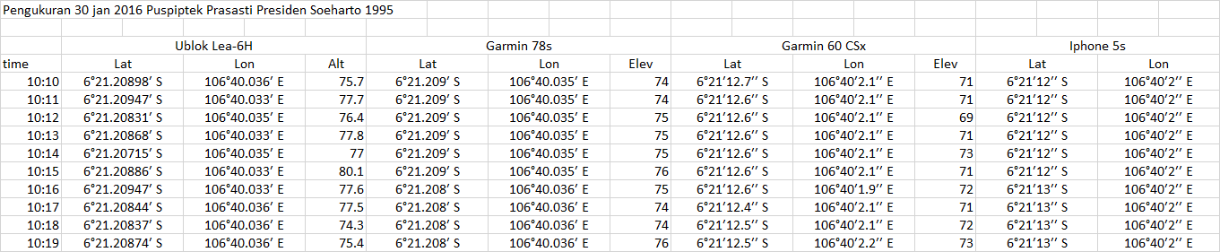

Latitude of GPS arduino was 6°21.20947′ S. This is equal to

(6 x 111.13294) + (21.20947 x 1.85221567) + 0 = 706.0821527 km

Latitude of GPS garmin 60 CSx was 6°21′12.6′′ S. This is same with

(6 x 111.13294) + (21 x 1.85221567) + (12.6 x 0.0308726117) = 706.083164 km

From the results of converting latitude and longitude into unit of length like the above example, graphs can be made to see the accuracy and stability of these tools when compared with the others. Figure 15 is an example of a gps accuracy comparison chart.

Figure 15. Longitude measurement at Monas, Jakarta

From the entire comparison chart results, it can be seen drastic changes from the data obtained by Iphone. This is caused by their resolution difference. The resolution of Iphone is 1 second for approximately 0.03 km (30 meters), while the garmin 60csx is 0.1 second (about 3 meters), garmin 78s is 0.001 minute (around 1.85 meters), and the GPS logger can display resolutions up to 0.00001 minute (around 0.0185 meters).

To measure the highest gps fluctuation, standard deviation calculations are performed for each measurement table. This is to ensure that the tool can provide constant information if it will be calibrated to a certain standard. The biggest standard deviation from all obtained data at the 2004 President Megawati inscription at Puspiptek for the latitude was 3,60582 meters and longitude was 3,736344.

The data was attained from 72 measurement samples. The data uncertainty was obtained by calculating repeatability and readability, and ignoring other sources of uncertainty[9]. The repeatability and readability are formulated by ISO.

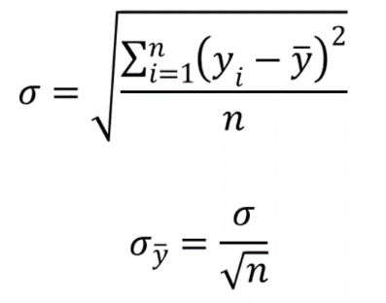

From the calculation of the standard deviation of 72 sample data, the values of latitude and longitude ware 1.434037719 m and 1.535183245 m respectively. The results of the repeatability of latitude and longitude gps logger ware 0.169002966 meters and 0.18092308 meters respectively.

The resolution standar uncertainty (readability) of the gps logger is processed using the formula:

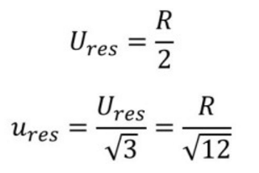

R is the resolution in the tool (0.00001 minute), but the resolution that was used only 0.001 minute, because based on the data, 0.00001 minute has too many fluctuations. Readability is 0.534688608 meters for latitude= 0.001 minute (1.85221567 meters) and latitude= 1.855331945 meters.

The error is attained by subtracting the data between gps logger and reference. These discrepancies are then averaged (Table 2). It is assumed that the reference tool has correct coordinates.

Error = gps logger – reference

Table 2. The average errors for latitude and longitude (km)



**5. CONCLUSION**

Based on the measurements data, the developed GPS logger was able to work in various locations and had the highest standard deviation at 3.60582 meters for latitude and 3.736344 meters for longitude. The resolution value should be displayed up to 0.001 minutes. This GPS had an average error less than 2 meters when was compared to Garmin GPS on the market.

**6. ACKNOWLEDGMENT**

The authors would like to thank to Jason Pratama - the student from Swiss German University with ID card 11501004 - for assisting in this research, and to the management of PUSPIPTEK for providing a place and facilities, so that this research activity could be well done.

**7. REFERENCES**

[1] TFT, *Itead Studio*, ( <https://www.itead.cc>, diakses terakhir 4 Januari 2017 )

[2] Singh, Bharat Raj & Ongkar Singk. 2014. Dire Consequences Likely to Happen if the Earth’s Spinning Angle Gets little Shifted – A Study Whether Fast Shrinkage of Polar Ice be the Cause. InTech.

[3] GPS, GPS information ([www.gpsinformation.org/dale/theory.htm](http://www.gpsinformation.org/dale/theory.htm) , diakses terakhir 27 Oktober 2016)

[4] Arduino, *Arduino Mega ADK* ([www.arduino.cc/en/Main/ArduinoBoard](http://www.arduino.cc/en/Main/ArduinoBoard)MegaADK, diakses terakhir 4 Januari 2017)

[5] Sidik, M.A.B., M.Q.A. Rusli, Z. Adzis, Z. Buntat, Y.Z. Arief, H. Shahroom, Z. Nawawi, M.I. Jambak. 2015. Arduino-Uno Based Mobile Data Logger with GPS feature. Indonesia.

[6] DFRobot, Arduino GPS Shield ublox LEA-6H ([www.dfrobot.com](http://www.dfrobot.com) , diakses terakhir 4 Januari 2017)

[7] Atmel ([www.atmel.com/devices/atmega2560.aspx](http://www.atmel.com/devices/atmega2560.aspx), diakses terakhir 4 Januari 2017)

[8] UTFT, UTFT library (<http://www.rinkydinkelectronics.com/library.php?id=51>, diakses terakhir 19 Januari 2017)

[9] Purwowibowo, Jalu Ahmad Prakosa. Prototipe Frekeunsi Meter Rentang Ukur (10~2000) Hz Terkalibrasi ke Standar Primer Frekuensi ke Standar Primer Frekuensi (Cesium). Puslit Metrologi LIPI.